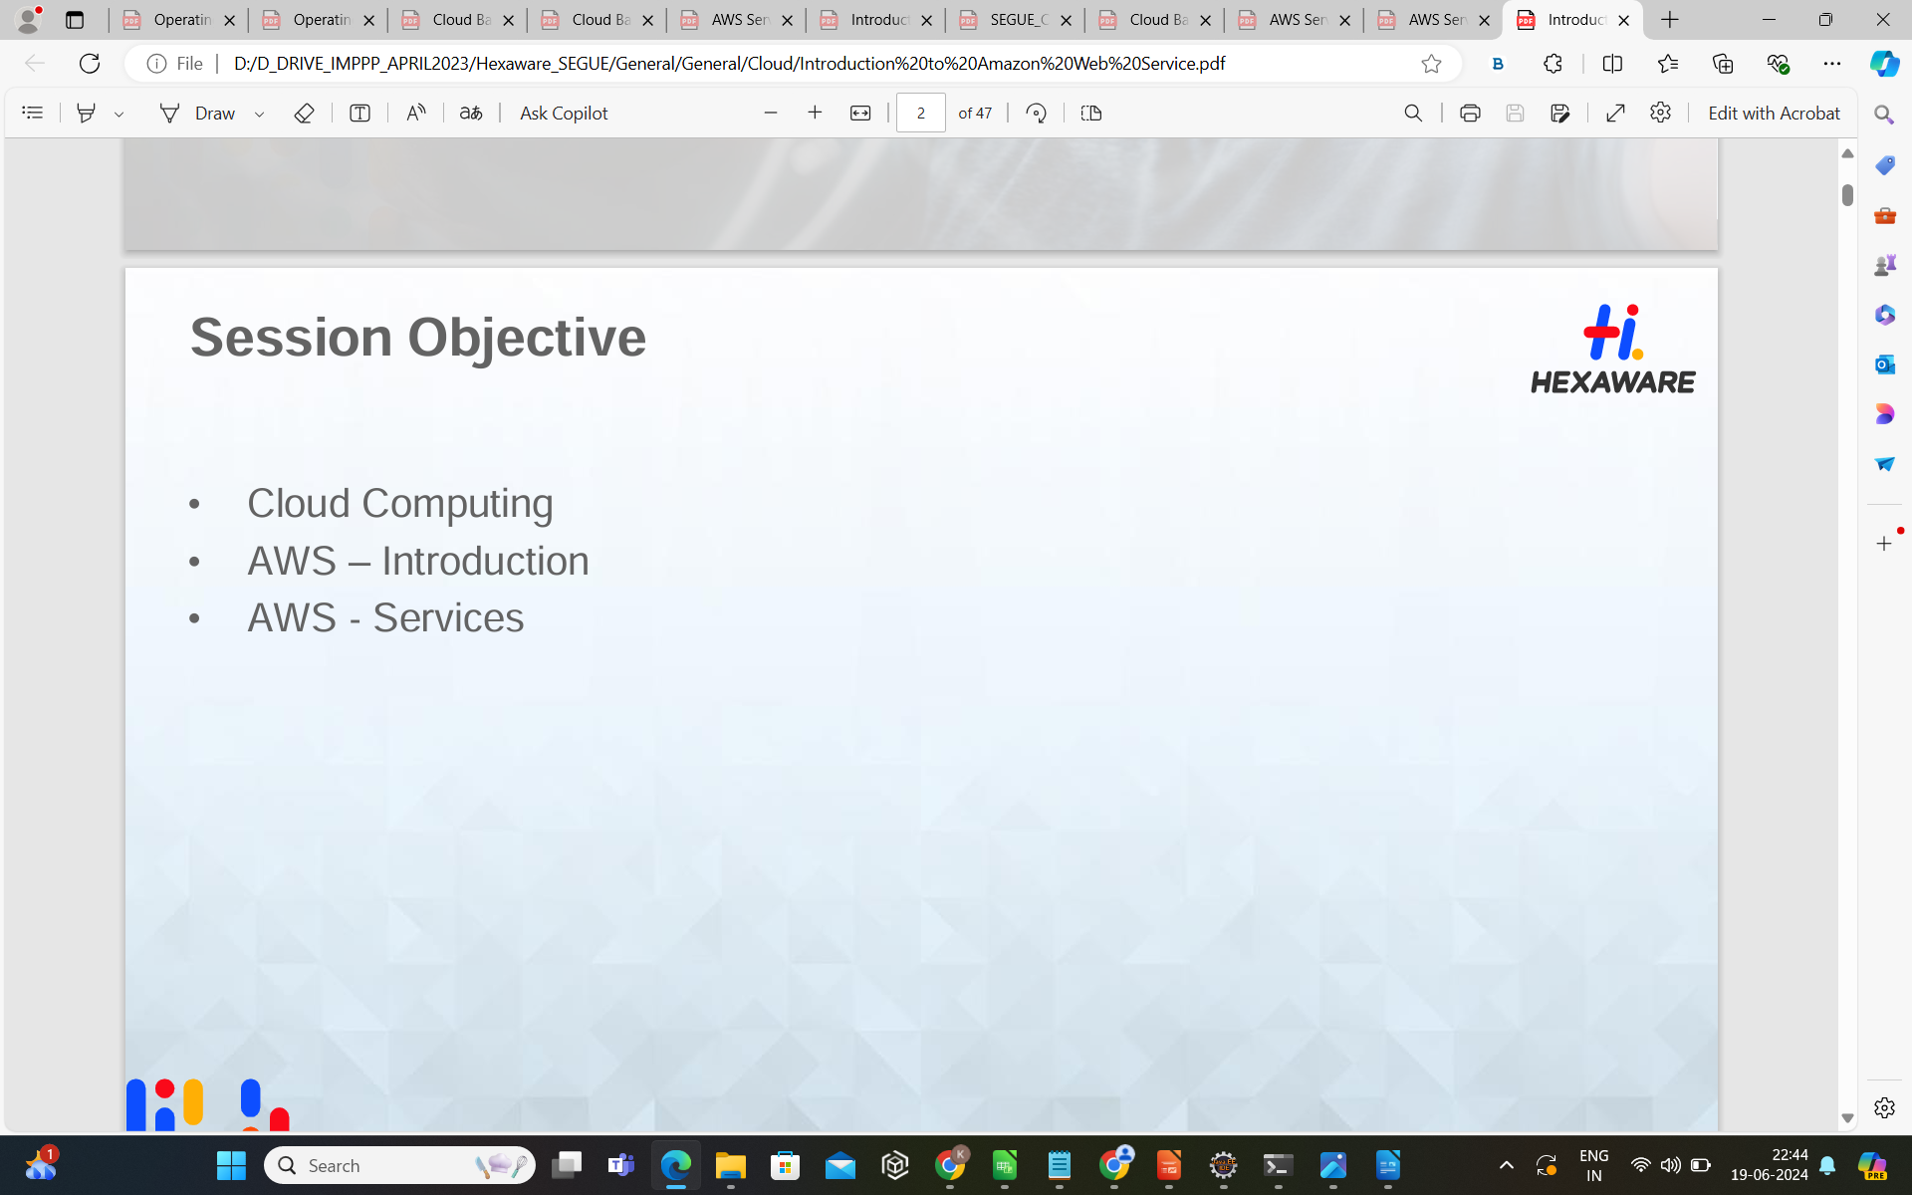

Cloud Computing

• Cloud computing is an internet-based computing service in which large groups of remote servers are networked to allow centralized data storage, and online access to computer services or resources.

• Using cloud computing, organizations can use shared computing and storage resources rather than building, operating, and improving infrastructure on their own

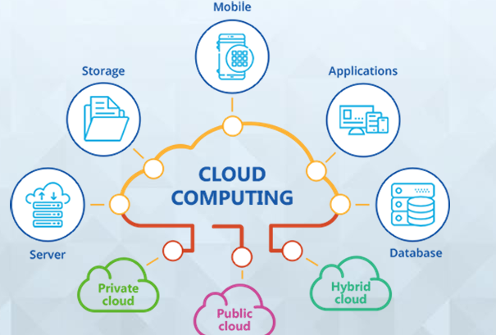

Cloud Computing Features::

Cloud computing is a model that enables the following features.

➢ Users can provision and release resources on-demand.

➢ Resources can be scaled up or down automatically, depending on the load.

➢ Resources are accessible over a network with proper security.

➢ Cloud service providers can enable a pay-as-you-go model, where customers are charged based on the type of resources and per usage.

Types of Clouds ::

There are three types of clouds ❖Public cloud ❖Private cloud ❖Hybrid cloud

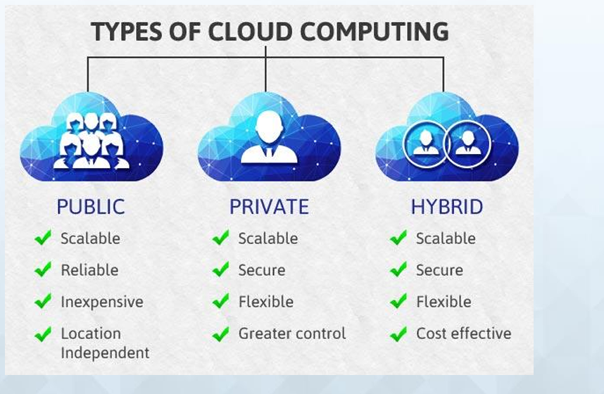

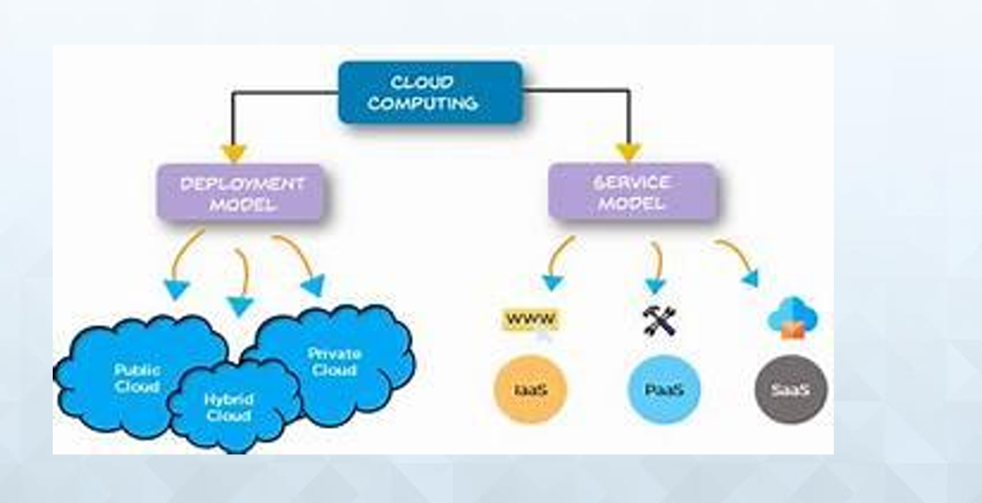

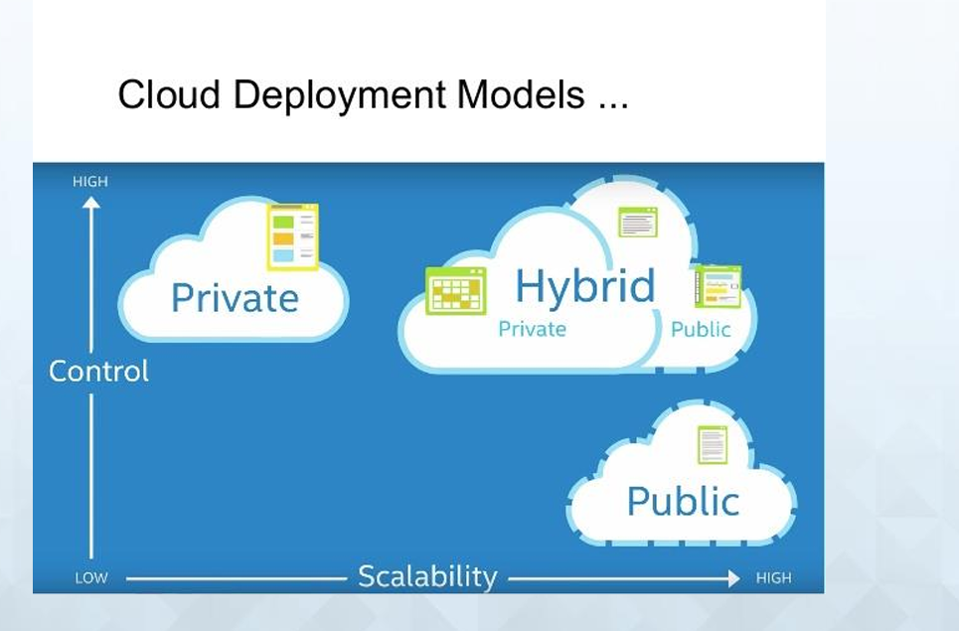

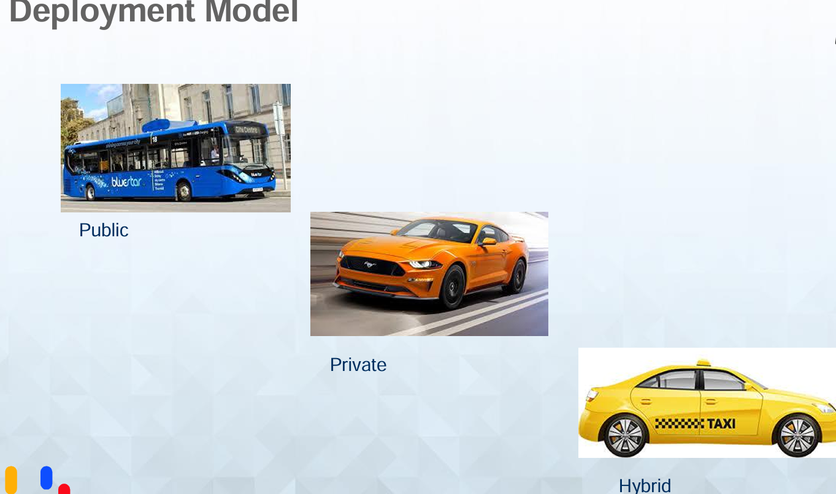

Deployment Model::

• Public Cloud

o In public cloud, the third-party service providers make resources and services available to their customers via Internet. Customer’s data and related security is with the service providers’ owned infrastructure.

• Private Cloud

o A private cloud also provides almost similar features as public cloud, but the data and services are managed by the organization or by the third party only for the customer’s organization. In this type of cloud, major control is over the infrastructure so security related issues are minimized.

Hybrid Cloud

o A hybrid cloud is the combination of both private and public cloud. The decision to run on private or public cloud usually depends on various parameters like sensitivity of data and applications, industry certifications and required standards, regulations, etc.

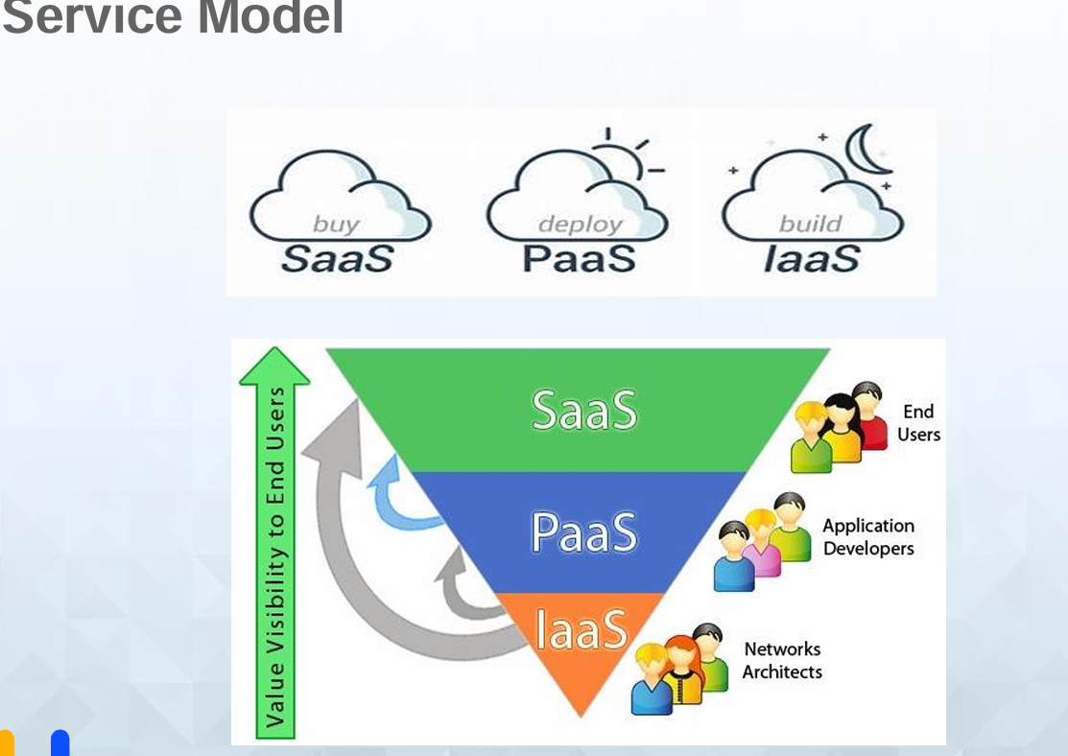

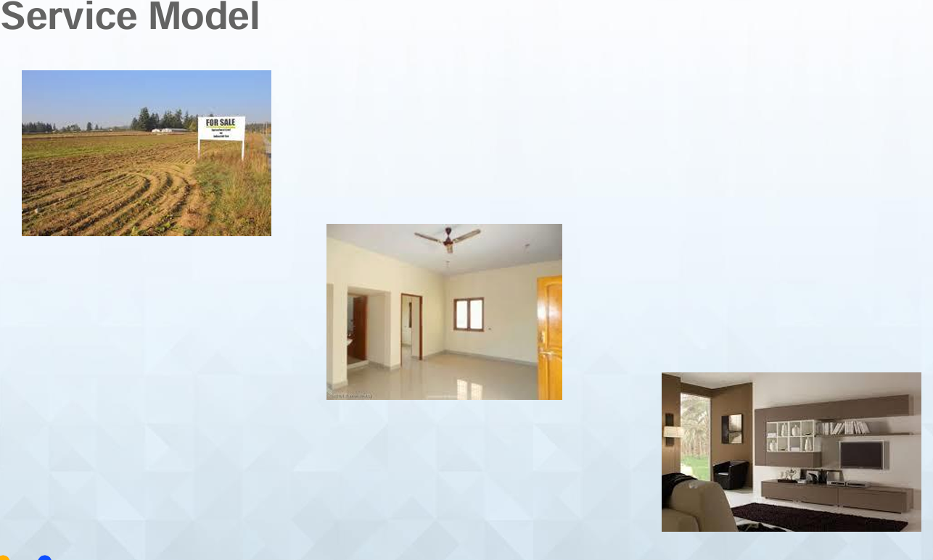

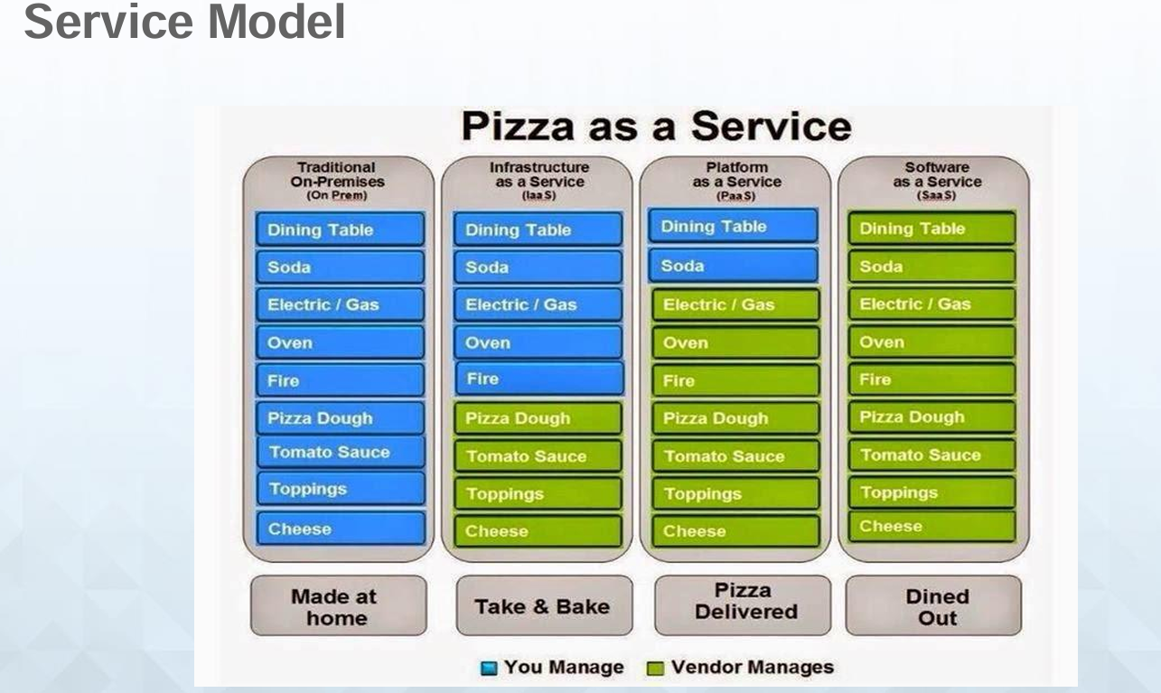

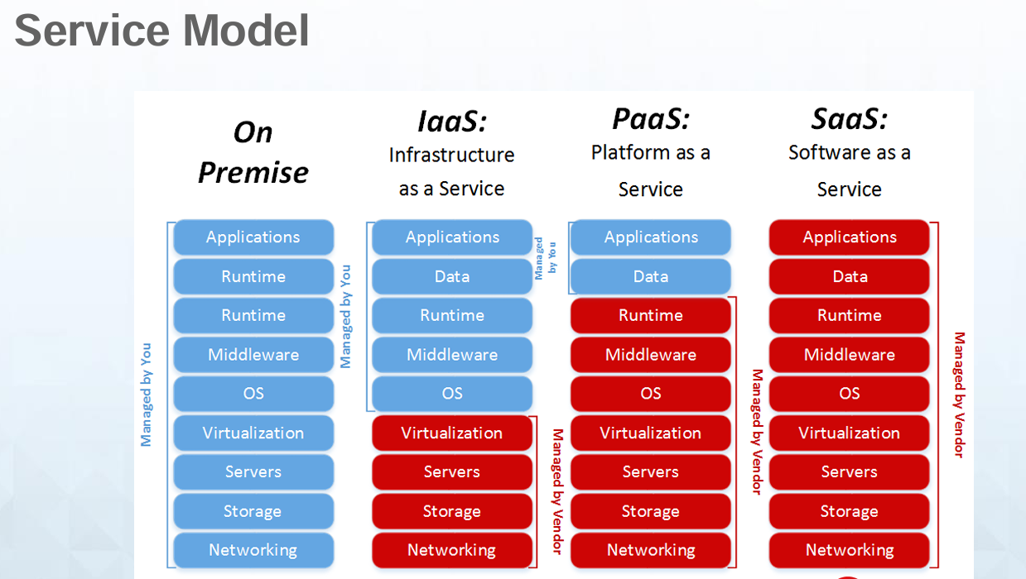

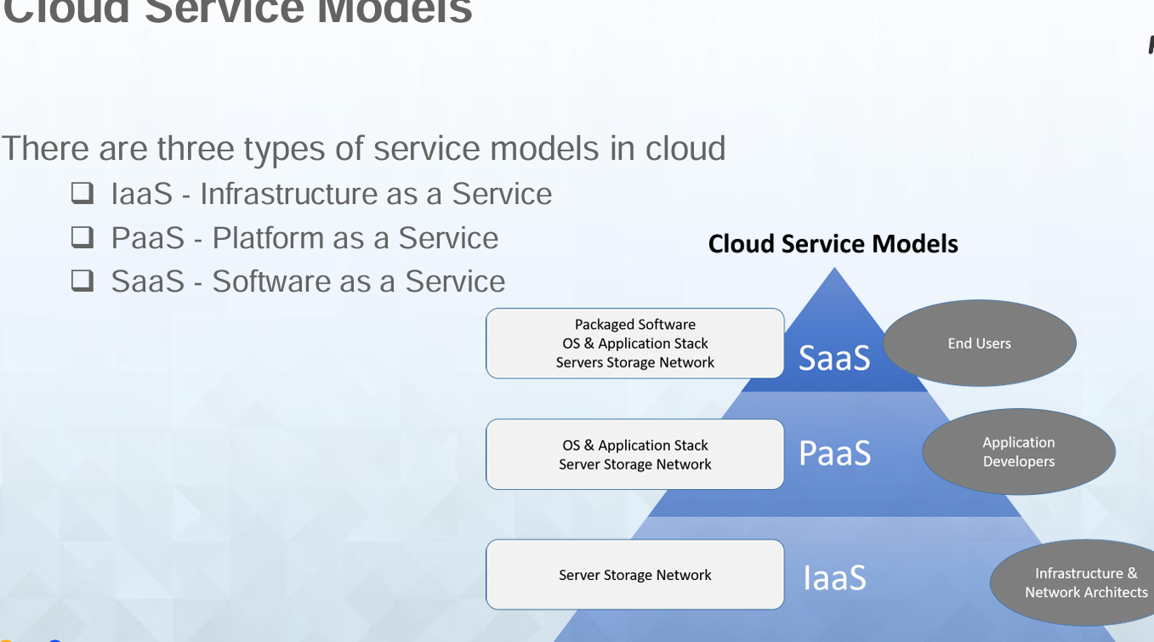

Advantages of Cloud Computing:

• Cost-Efficient ➢ Building our own servers and tools is time-consuming as well as expensive as we need to order, pay for, install, and configure expensive hardware, long before we need it. ➢ Using cloud computing, we only pay for the amount we use and when we use the computing resources. In this manner, cloud computing is cost efficient.

• Reliability ➢ A cloud computing platform provides much more managed, reliable and consistent service than an in-house IT infrastructure. ➢ It guarantees 24x7 and 365 days of service. If any of the server fails, then hosted applications and services can easily be transited to any of the available servers.

• Backup & Recovery ➢ Storing data in the cloud, backing it up and restoring the same is relatively easier than storing it on a physical device. ➢ The cloud service providers also have enough technology to recover our data, so there is the convenience of recovering our data anytime.

• Easy Access to Information ➢ Once you register yourself in cloud, you can access your account from anywhere in the world provided there is internet connection at that point. ➢ There are various storage and security facilities that vary with the account type chosen.

--Unlimited Storage ➢ Cloud computing provides almost unlimited storage capacity, i.e., we need not worry about running out of storage space or increasing our current storage space availability. We can access as much or as little as we need.

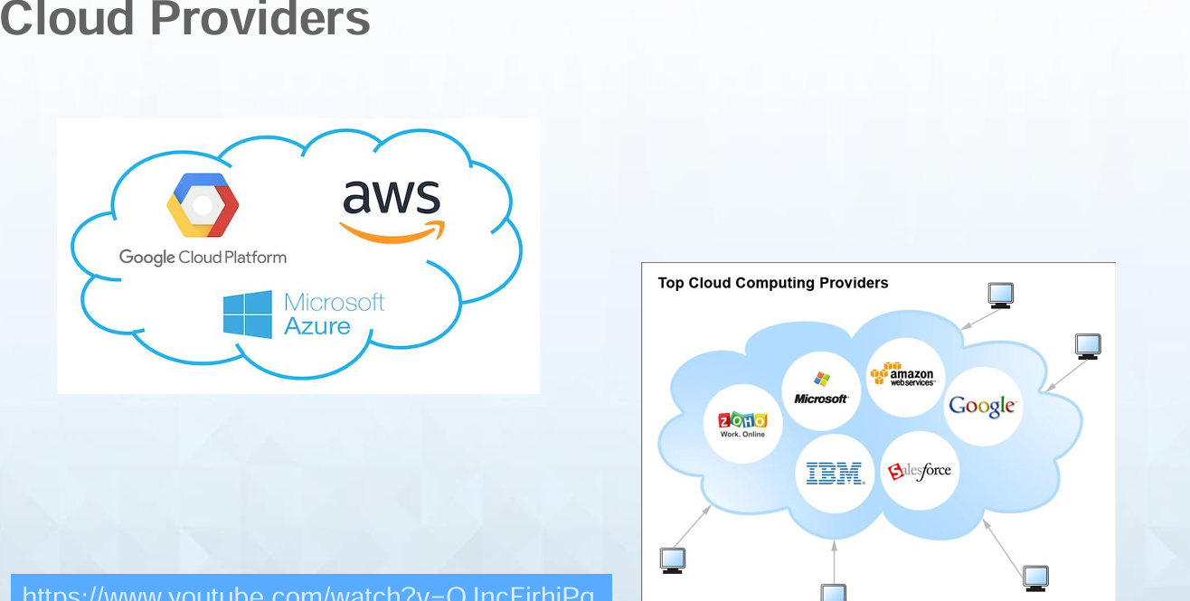

What is AWS?

•Amazon Web Services(AWS) is a cloud service from Amazon, which provides services in the form of building blocks, these building blocks can be used to create and deploy any type of application in the cloud.

• These services or building blocks are designed to work with each other, and result in applications which are sophisticated and highly scalable

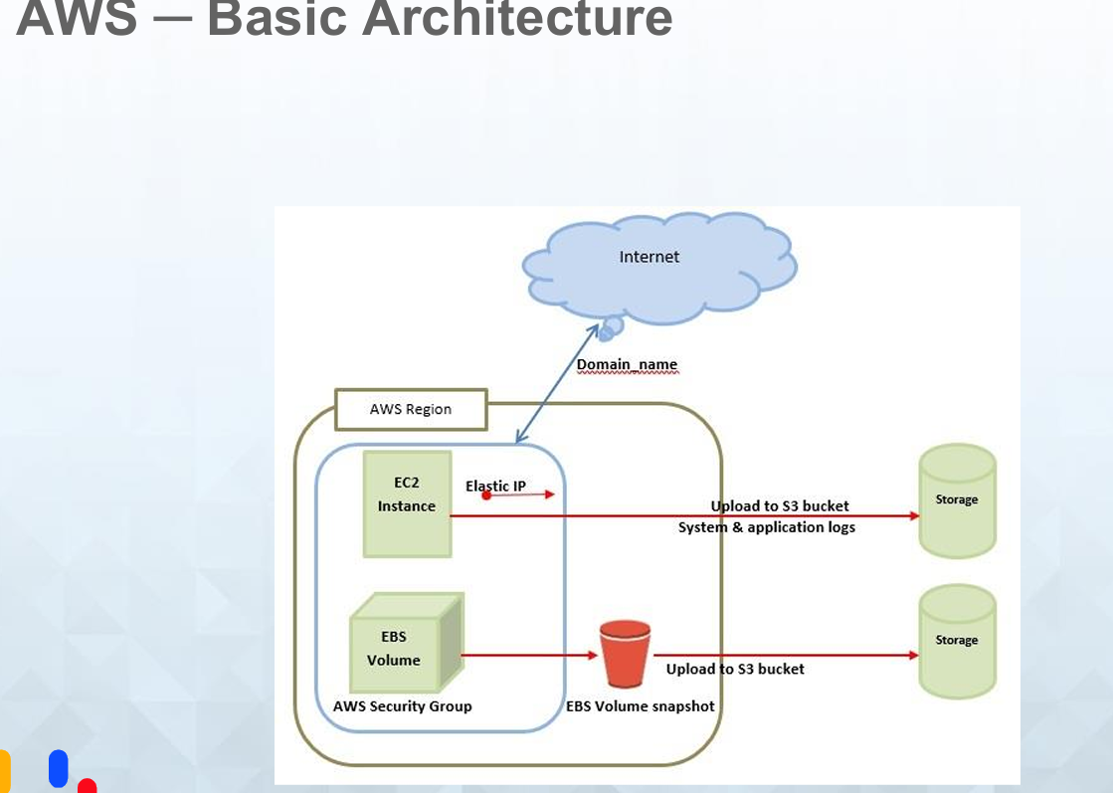

AWS Introduction

• Cloud computing is the on-demand delivery of compute power, database storage, applications, and other IT resources through a cloud services platform.

• Cloud computing provides a simple way to access servers, storage, databases and a broad set of application services over the Internet.

• A cloud services platform such as Amazon Web Services owns and maintains the network-connected hardware required for these application services

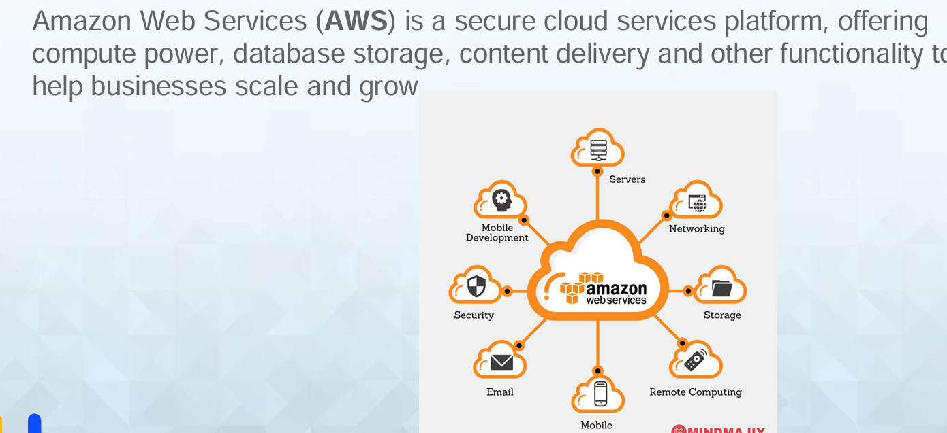

AWS Example::

